# Third Moment: Skewness

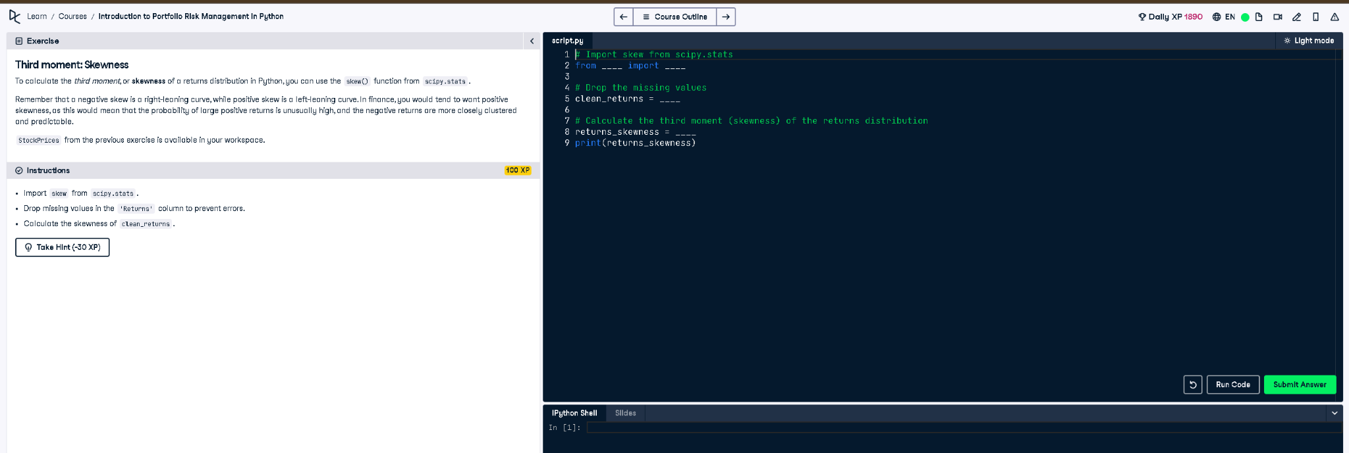

## Python Code

# Import skew from scipy.stats  
from scipy.stats import skew  
  
# Drop the missing values  
clean_returns = StockPrices['Returns'].dropna()  
  
# Calculate the third moment (skewness) of the returns distribution  
returns_skewness = skew(clean_returns)  
print(returns_skewness)

## Explanation (Simple Words)

To measure skewness (third moment), we first remove missing values from the returns. Then, we use `skew()` from `scipy.stats` to compute how returns are asymmetrically distributed. Positive skew means more small losses and rare big gains; negative skew is the opposite, indicating common small gains and rare big losses.